The history of Java is very interesting. Java was originally designed for interactive television, but it was too advanced technology for the digital cable television industry at the time. The history of Java starts with the Green Team. Java team members (also known as Green Team), initiated this project to develop a language for digital devices such as set-top boxes, televisions, etc. However, it was suited for internet programming. Later, Java technology was incorporated by Netscape.
The principles for creating Java programming were "Simple, Robust, Portable, Platform-independent, Secured, High Performance, Multithreaded, Architecture Neutral, Object-Oriented, Interpreted, and Dynamic". Java was developed by James Gosling, who is known as the father of Java, in 1995. James Gosling and his team members started the project in the early '90s.

Currently, Java is used in internet programming, mobile devices, games, e-business solutions, etc. There are given significant points that describe the history of Java.

Java Version History
Many java versions have been released till now. The current stable release of Java is Java SE 10.
- JDK Alpha and Beta (1995)
- JDK 1.0 (23rd Jan 1996)
- JDK 1.1 (19th Feb 1997)
- J2SE 1.2 (8th Dec 1998)
- J2SE 1.3 (8th May 2000)
- J2SE 1.4 (6th Feb 2002)
- J2SE 5.0 (30th Sep 2004)
- Java SE 6 (11th Dec 2006)
- Java SE 7 (28th July 2011)
- Java SE 8 (18th Mar 2014)
- Java SE 9 (21st Sep 2017)
- Java SE 10 (20th Mar 2018)
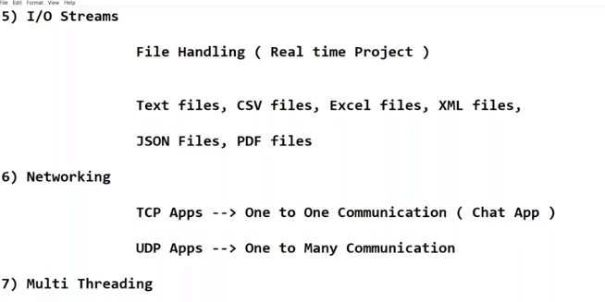
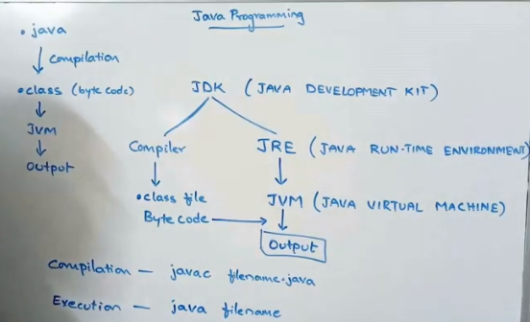

Features of Java

To describe java pl nature java prog has provided a set of features
- Simple
- Object-Oriented
- Portable
- Platform independent
- Secured
- Robust
- Architecture neutral
- Interpreted
- High Performance
- Multithreaded
- Distributed
- Dynamic

- Simple
  - Java syntax is based on c and C++ (so easier for programmers to learn it after C++).
  - Java has removed many complicated and rarely-used features, for example, multiple inheritance, pointers, operator overloading, etc.
  - There is no need to remove unreferenced objects because there is an Automatic Garbage Collection in Java.
  - Java applications are able to take less memory and less execution time.

Object-oriented
Java is an object-oriented programming language. Everything in Java is an object. Object-oriented means we organize our software as a combination of different types of objects that incorporates both data and behavior.
Object-oriented programming (OOPs) is a methodology that simplifies software development and maintenance by providing some rules.

Platform Independent
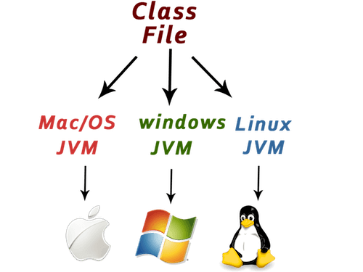
Java is platform independent because it is different from other languages like C, C++, etc. which are compiled into platform specific machines while Java is a write once, run anywhere (WORA)language. A platform is the hardware or software environment in which a program runs.
There are two types of platforms software-based and hardware-based. Java provides a software-based platform.
Java code can be run on multiple platforms, for example, Windows, Linux, Sun Solaris, Mac/OS, etc. Java code is compiled by the compiler and converted into bytecode. This bytecode is a platform-independent code because it can be run on multiple platforms, i.e., Write Once and Run Anywhere(WORA).
- Architecture neutral
Java allows its applications to perform compilation on one h/w sys and to perform execution on other system.
Java is architecture neutral because there are no implementation dependent features, for example, the size of primitive types is fixed.
In C programming, int data type occupies 2 bytes of memory for 32-bit architecture and 4 bytes of memory for 64-bit architecture. However, it occupies 4 bytes of memory for both 32 and 64-bit architectures in Java.

Portable
Java allows its applications under all the o.s. and under all h/w system. Eg : 3 billion devices
Java is portable because it facilitates you to carry the Java bytecode to any platform. It doesn't require any implementation.
- Robust
Robust simply means strong. Java is robust because:
- It uses strong memory management. (DMA) ---heap mem
- There are exception handling and the type checking mechanism in Java. All these points make Java robust. --- having library to handle it
- Dynamic :
Java is a dynamic language. It allows mem allocation for primitive data types at run time not at compile time .It supports dynamic loading of classes. It means classes are loaded on demand. It also supports functions from its native languages, i.e., C and C++.
Java supports dynamic compilation and automatic memory management (garbage collection).
- Secure :
Java is best known for its security. With Java, we can develop virus-free systems. Java is secured because:
Implicit security : security mgr inside JVM ( bytecode is correct or not eg)
Websecurity: JAAS (java authorization and AUTHANTICATION SERVICES)
Networksecurity :Java has provided predefined implementations for all NW SEC ALGO which we are using frequently in java programming.

Distributed
Standalone and distributed programs.
Java is distributed because it facilitates users to create distributed applications in Java. j2ee /java ee,java has provided a separated module… are used for creating distributed applications. This feature of Java makes us able to access files by calling the methods from any machine on the internet.

10 .Multi-threaded
A thread is like a separate program, executing concurrently. We can write Java programs that deal with many tasks at once by defining multiple threads. The main advantage of multi-threading is that it doesn't occupy memory for each thread. It shares a common memory area. Threads are important for multi-media, Web applications, etc.It improves CPU utilization.

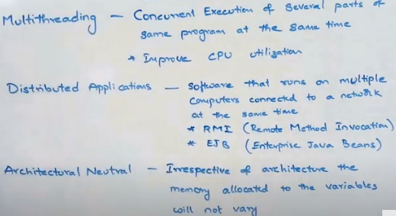
  - INTERPRETIVE
Java is compilative pl because to translate prog from hl to low level repress. And to chk java developers mistakes in prog we need compilation.
To execute java applications we need an interpreter inside so java is an interpretive lang
Java byte code is translated on the fly to native machine instructions and is not stored anywhere. The development process is more rapid and analytical since the linking is an incremental and light-weight process.
  - HIGH Performance
Java is faster than other traditional interpreted programming languages because
Java is having rich set of feature….
Its internal components like JIT (Just in time )Compiler.

